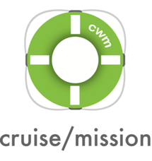
(Date)
To whom it may concern,
(Student’s name) is seeking time away from school to attend Cruise with a Mission (CWM), a special mission trip experience for young people. This trip to Mexico will take place December 12-19, 2021. (Student’s name) is uniquely positioned to benefit from participating in this mission and hopes to deepen their relationship with God if they are given school accommodations.
The annual CWM trip typically involves young adults from all over North America and many times from around the world. This 7-day mission trip will include visiting port cities where (student’s name) will experience culture through food, music, language, and physical labor that includes time with local community members and leaders.
At each “mission port” (student’s name) will be involved in a service project requested by the community. This project will give (him/her) the opportunity to connect with the local culture and the basic felt needs of that community. These service projects will take (him/her) beyond the “tourist trap” experience into the heart of “real world” communities.
Mia’s faith will also be strengthened by the on-ship CWM programming. The mission trip leaders have organized daily gatherings for physical, spiritual, social, and personal growth. The invited speaker, (speaker’s name) will give encouraging messages based on the theme for this year, “(list theme here)”. These professionally organized meetings give students unique opportunities to confront life goals in the context of their strengths and weaknesses.
Cruise with a Mission is an annual young adult trip that has been offered for 10 years and has involved close to 1,000 cruisers.
Thank you for supporting (student’s name) in (his/her) heartfelt desire to participate in this unique mission trip experience.
If you have questions, please contact me.

Ron Whitehead
Assistant Professor Andrews Univ.
Director Center for Youth Evangelism
Executive Director International Camporee
Director Youth Ministry Lake Union Conference
Whitehead@andrews.edu – 269-208-1344

